Introduction

Problem Statement

Is crime in America rising or falling? The answer is not as simple as politicians make it out to be because of how the FBI collects crime data from the country’s more than 18,000 police agencies. National estimates can be inconsistent and out of date, as the FBI takes months or years to piece together reports from those agencies that choose to participate in the voluntary program.

To try to fill this gap, The Marshall Project collected and analyzed more than 40 years of data on the four major crimes the FBI classifies as violent — homicide, rape, robbery and assault — in 68 police jurisdictions with populations of 250,000 or greater. We obtained 2015 reports, which have yet to be released by the FBI, directly from 61 of them. We calculated the rate of crime in each category and for all violent crime, per 100,000 residents in the jurisdiction, based on the FBI’s estimated population for that year. We used the 2014 estimated population to calculate 2015 crime rates per capita.

Acknowledgements

The crime data was acquired from the FBI Uniform Crime Reporting program's "Offenses Known and Clearances by Arrest" database for the year in question, held at the National Archives of Criminal Justice Data. The data was compiled and analyzed by Gabriel Dance, Tom Meagher, and Emily Hopkins of The Marshall Project; the analysis was published as [Crime in Context](https://www.themarshallproject.org/2016/08/18/crime-in-context) on 18 August 2016.

Literature Review

Data Exploration

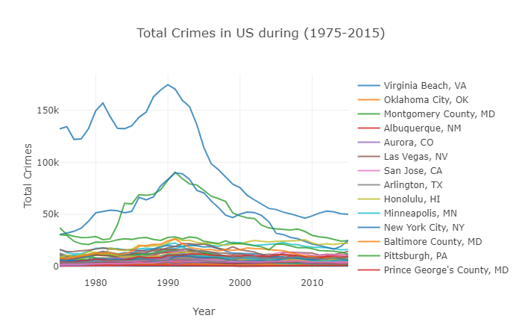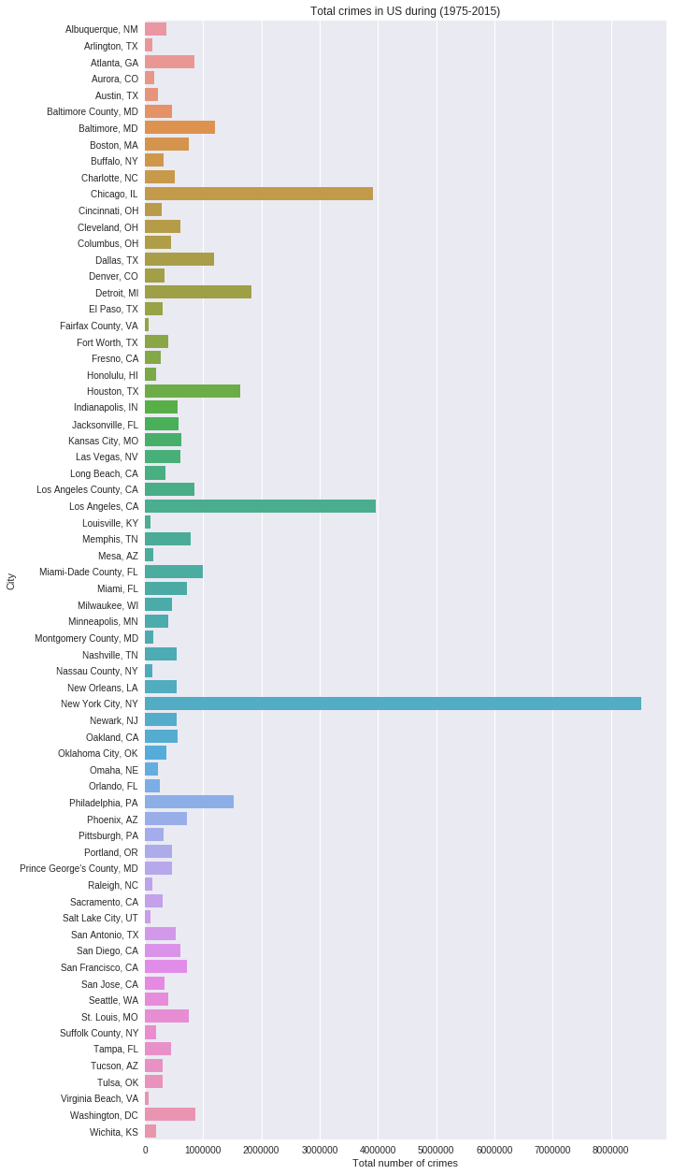

Analysis & Interpretation

Appendix: R script